Hip Hop, Jazz-Hip Hop, TikTok, & Breaking Dress Code
All items to be purchased either in-studio or through Discount Dance Supply by using the link on our website

- Studio T-Shirt OR Dress Code Leotard: White-Beginning, Gray- Intermediate, Black- Advanced
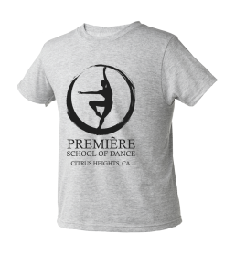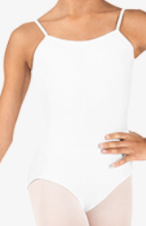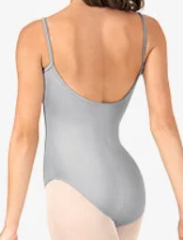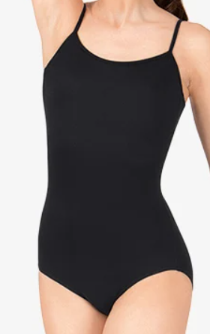
Style# CL5607
- Black Hip Hop Pants
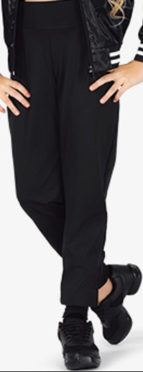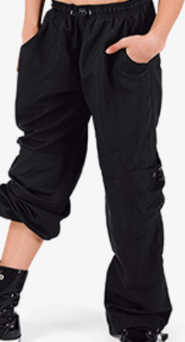
Style # N8862C OR Style# BP104
- Black Dance Shoes
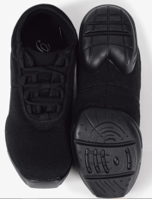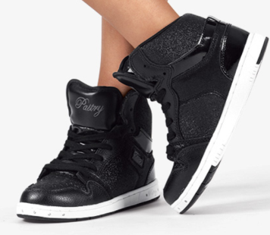
Style# T8001 OR Style #PK143300

