Primary Level Dress Code (Ages 2-7)
All items to be purchased either in-studio or through Discount Dance Supply by using the link on our website

- Pink Leotard:
Tank OR Long Sleeve
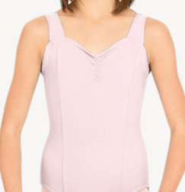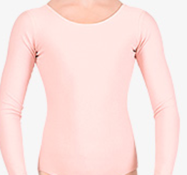
Style# N5501C, Style# D5103C

- Pink Skirt for Ballet, Black Shorts OR Pants for Tap and Jazz:
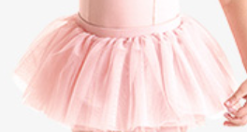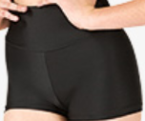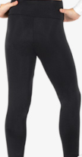
Style# CR4041, Style # N8641C, Style# N8642MC

- Pink Ballet Shoes, Carmel Jazz Shoes, Black Tap Shoes, White ruffle socks
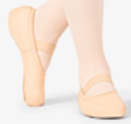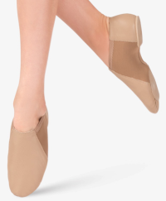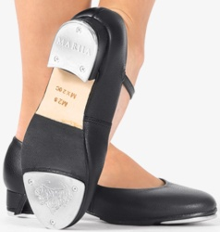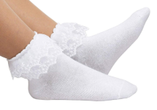
Style# MX12CPNK, Style# MX16CCAR, Style # MX20CBLK, (Please purchase white ruffle socks separately)

