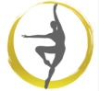
Alternate Dress Code
All items to be purchased either in-studio or through Discount Dance Supply by using the link on our website

- Fitted T-shirt- White for Levels Primary & Beginning, Gray for Level Intermediate, Black for Level Advanced
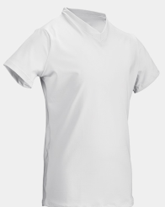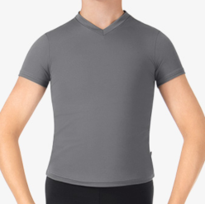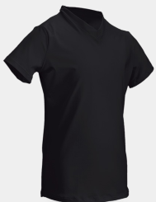
Style#ME810C

- Pants/ Tights Black
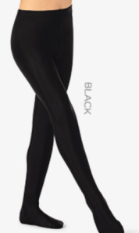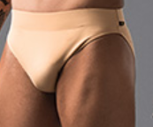
Style#TH5135C, Style# B192, Style# ME820

- Ballet Shoes (White for Levels Primary & Beginning, Black for Level Intermediate & Advanced), Black Jazz Shoes, Black Tap Shoes
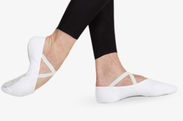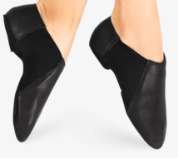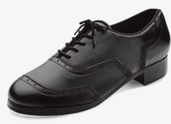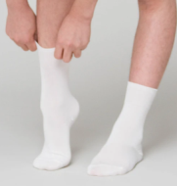
Style# So205G, 2021, Style# MX16C, So401, Style# T9100C, So313, (Please purchase White Socks separately)

