Advanced Level Dress Code
All items to be purchased either in-studio or through Discount Dance Supply by using the link on our website

- Leotard(Black)
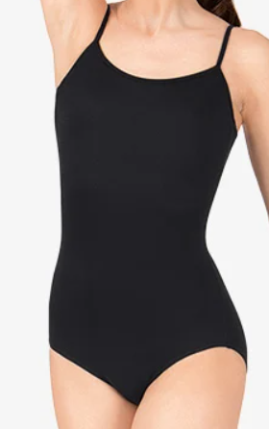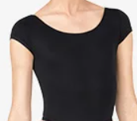
Style# L5607, Style# L5602

- Tights for Ballet(Pink), Tights for Tap, Jazz, Acro, and Contemporary(Skin Tone)
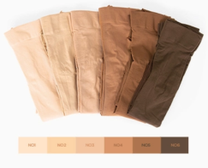
Style # T5515C, Style # MTB10

- Belt for Ballet(Pink), Shorts for Tap, Jazz, Acro, and Contemporary(Black)
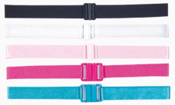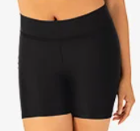
Style#62ADJ, Style# TH5106

- Ballet Shoes(Pink), Tap Shoes(Black), Jazz Shoes(Caramel), Acro and Cont. Shoes(Nude)
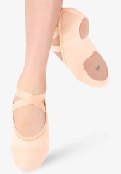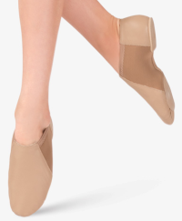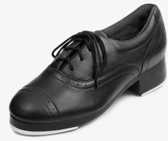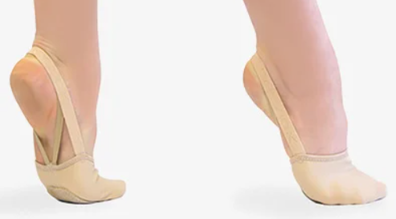
Style# MX14C, Style# MX16CCAR, Style# S0313L, Style# H064W

