Primary Level Dress Code (Ages 2-7)
All items to be purchased either in-studio or through Discount Dance Supply by using the link on our website

- Leotard (Pink):
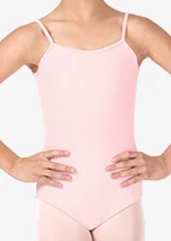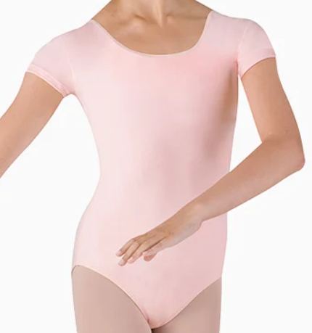
Style#CL5607, Style#CL5602

- Skirt for Ballet (Pink), Shorts for Tap and Jazz (Black):
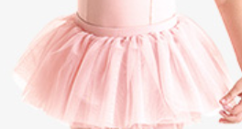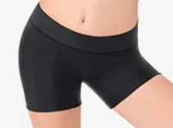
Style# CR4041, Style # TH5106C

- Ballet Shoes(Pink), Jazz Shoes(Carmel), Tap Shoes (Black), Ruffle socks(White)
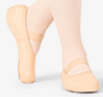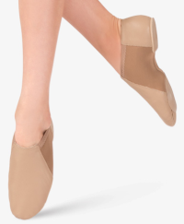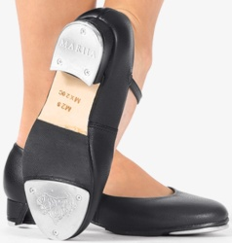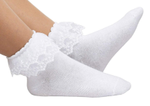
Style# MX12CPNK, Style# MX16CCAR, Style # MX20CBLK, (Please purchase white ruffle socks separately)

