Intermediate Level Dress Code
All items to be purchased either in-studio or through Discount Dance Supply by using the link on our website

- Charcoal/ Silver Leotard: Camisole OR Long Sleeve (Adult Sizes Only)
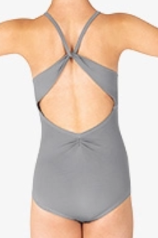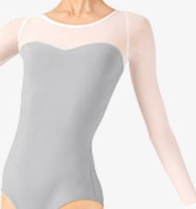
Style# BT5248C, Style# ME542

- Pink Tights for Ballet, Skin Tone Tights for Tap, Jazz, and Contemporary
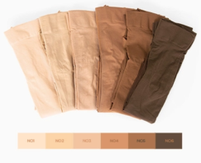
Style # T5515C, Style # MTB10

- Belt (LEVEL 2 & 3 ONLY) for Ballet, Black Shorts OR Pants for Tap, Jazz, and Contemporary
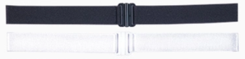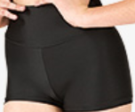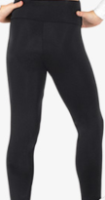
Style#62ADJ, Style# N8641C, Style# N8642MC

- Pink Ballet Shoes, Black Tap Shoes, Caramel Jazz Shoes
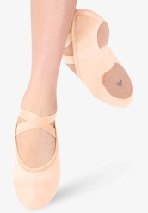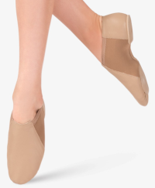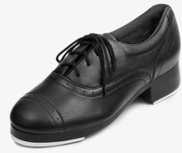
Style# MX14C, Style# MX16CCAR, Style# S0313L

