Beginning Level Dress Code (Ages 7-12)
All items to be purchased either in-studio or through Discount Dance Supply by using the link on our website

- Leotard(White):
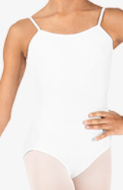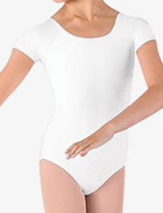
Style# CL5607, Style# CL5602
- Tights for Ballet(Pink), Tights for Tap, Jazz, Acro, and Contemporary(Skin Tone)
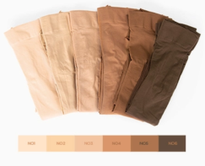
Style# T5515C, Style# MTB10
- Belt (LEVEL 2 & 3 ONLY) for Ballet, Shorts for Tap, Jazz, Acro, and Contemporary(Black)
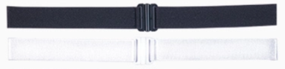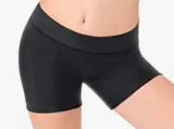
Style# 62ADJ, Style# TH5103C
- Ballet Shoes(Pink), Jazz Shoes(Caramel), Tap Shoes(Black), Cont. and Acro Shoes(Nude)
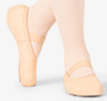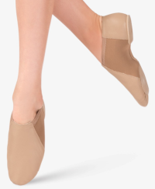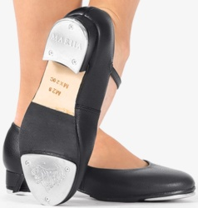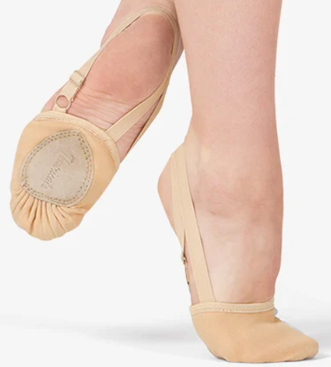
Style# MX12CPNK, Style# MX16CCAR, Style # MX20CBLK, Style# T8975

